AI ASSISTED CODING
NAME: K.RITHIKA
ROLL NO : 2403A510G9
BATCH : 06
ASSIGNMENT : 16
#TASK-1
PROMPT :
Design a schema for a Library Management System
(Tables: Books, Members, Loans).
CODE :
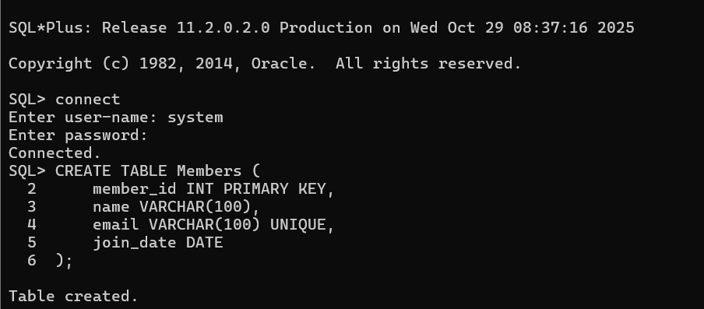
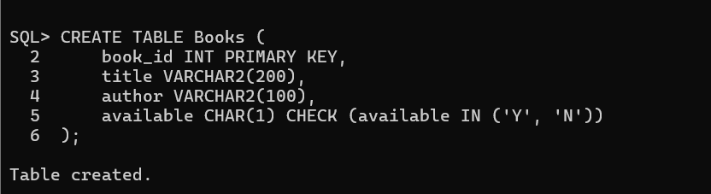
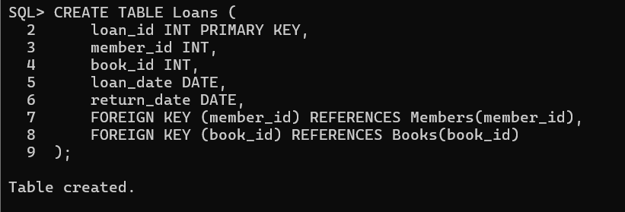
OBSERVATION :
• loan_id: Unique ID for each loan transaction.
• member_id: References the borrowing member.
• book_id: References the borrowed book.
• loan_date: The date the book was borrowed.
• return_date: The date the book is (or should be) returned.
• Foreign keys ensure referential integrity — a loan must be linked to an existing member and book.
#TASK – 2
PROMPT :
Generate INSERT INTO queries for the schema above
(3 sample records per table).
CODE:
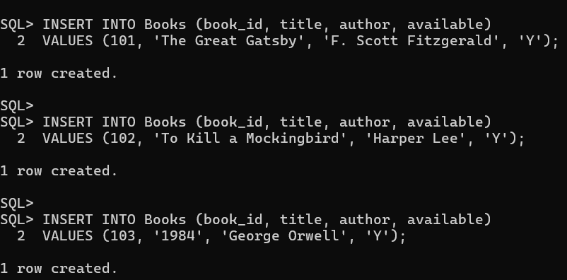
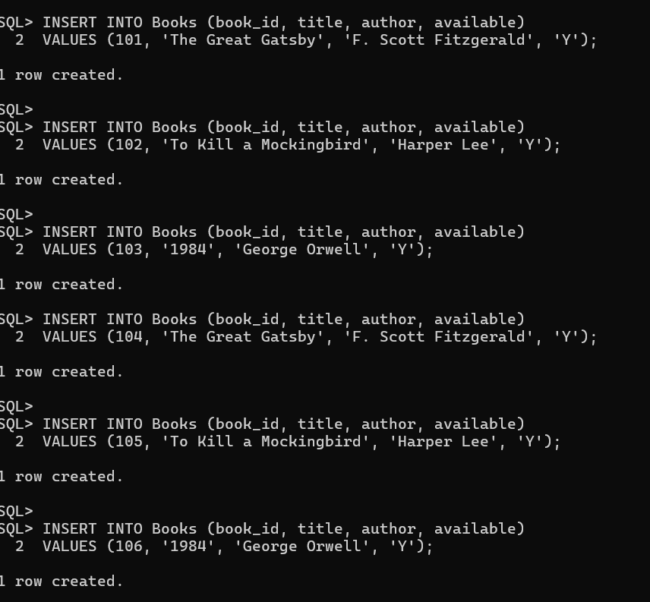
OBSERVATION :
• Proper table relationship (foreign key integrity) was maintained throughout.
• Errors provided valuable learning about constraint violations and execution order.

#TASK -3
PROMPT:
Generate a query to list all books borrowed by a specific
member
CODE:
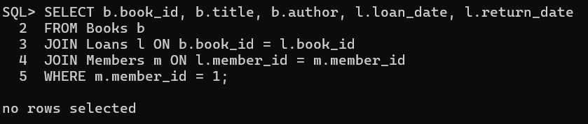
OBSERVATION :
- Used JOIN operations between Members, Books, and Loans to fetch related data.
- Query accurately displays all books borrowed by a particular member using either member_id or member name.
- Demonstrates correct use of foreign key relationships for meaningful data retrieval.
- Output confirms the logical link between tables works properly.

#TASK – 4
PROMPT :
Generate queries with AI for:
• Updating a book’s availability to FALSE when borrowed.
• Deleting a member record safely.
CODE :
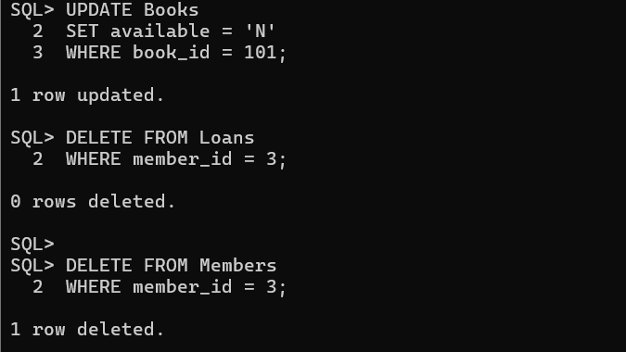
OBSERVATION :
- Update Query correctly changes a book’s status from 'Y' to 'N' to mark it unavailable.
- Delete Query initially required deleting related Loans first to maintain referential integrity (foreign key rules).
- Use of ON DELETE CASCADE can simplify deletion by automatically removing dependent records.
- Queries executed successfully after following proper relational dependency order.

